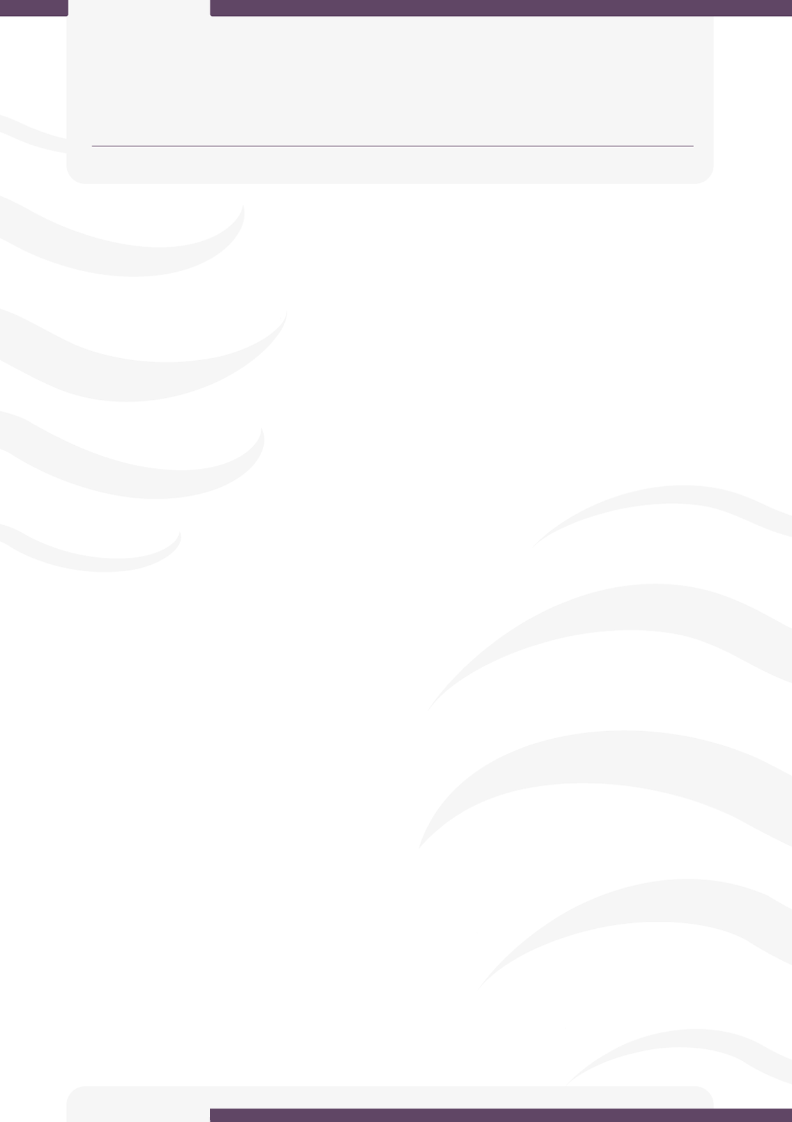
[WEDE5020w]
[Mywebsite proposals.
Titus Matandaware
ST10539519]
IIE- [ROSEBANK COLLEGE]
Organization 1
Small Business(fictional)

Organization name: Baked by Bee (Pty) Ltd

Brief history: Baked by bee began in 2019 as a small home-based baking venture, started by founder Tee out of a passion for baking that grew from weekend experiments in her family kitchen. What started as birthday cakes for friends and family quickly gained attention through word-of-mouth and social media

Mission and Vision: To create handcrafted, high-quality baked goods that bring joy to life's most memorable moments.
Target audience: the primary audience would be the event-planners, celebrants, local families, individuals and young adults interested in the design and the taste of the products.

WEBSITE GOALS AND OBJECTIVES

- Enable customers to submit custom cake/order inquiries through a contact or order form
- Build a gallery/portfolio page displaying past work (cakes, cupcakes, dessert tables) to build trust and inspire orders
- Clearly display operating hours, location/delivery area, contact details, and lead times for orders

CURRENT WEBSITE
Operates without a dedicated website. Their online presence is only limited to social media especially TikTok for marketing and orders.

Proposed website features and functionality

- Homepage
· Eye-catching banner/hero image showcasing signature cakes
· Brief intro to the brand

- About Us
· Founder's story and background
· Mission and vision statements

- Products/Gallery Page
· Categorized product showcase (birthday cakes, wedding cakes, cupcakes, dessert tables)
· High-quality images of past work

- Order/Custom Request Page
· Order inquiry form (event date, cake type, flavor, budget, design preferences)
· Lead time and deposit information

- Contact Us Page
· Location/delivery area info
· Business hours

Design and user experience
Colour Scheme
A warm, pastel-inspired palette that reflects the softness and sweetness of baked goods:
- Primary: Blush Pink (#F8C8DC) — warmth, femininity, sweetness
- Secondary: Cream/Ivory (#FFF8F0) — clean background, evokes icing/dough
- Accent: Rose Gold/Caramel Brown (#C08552) — luxury, baked texture, premium feel
- Text: Charcoal Grey (#3A3A3A) — for readability against light backgrounds
Typography
- Headings: A playful, elegant script or serif font (e.g., Playfair Display or Pacifico) to convey a handcrafted, boutique feel
- Body Text: A clean, easy-to-read sans-serif (e.g., Poppins or Lato) for descriptions, contact info, and navigation — ensuring accessibility and clarity
- Hierarchy: Larger script fonts for page titles/product names; smaller sans-serif for body copy, buttons, and forms
Layout and Design
- Clean, image-forward layout that lets cake photography take center stage
- Grid-based product gallery for easy browsing by category (birthday, wedding, cupcakes, etc.)
- Generous white space to avoid clutter and keep the design feeling premium, not busy
- Consistent card-style design for products and testimonials
- Mobile-first responsive design, since most customers will discover the brand via TikTok/Instagram on their phones
User Experience Considerations
- Navigation: Simple, sticky top navbar (Home, About, Products, Order, Contact) so users can access key pages from anywhere on the site
- Layout flow: Homepage guides visitors naturally from brand intro → featured products → call-to-action (order now/contact)
- Colour scheme usability: High contrast between text and background ensures readability; accent colour used sparingly for buttons/CTAs to draw attention without overwhelming
- Accessibility: Alt text for all images, legible font sizes, and touch-friendly buttons for mobile users
- Load speed: Optimized/compressed images so the photo-heavy gallery doesn't slow down the site
Site maps and hierarchy charts

Technical requirements
Domain Name
- Suggested domain: www.Bakedbybeeco.za (or .com if targeting a broader audience)
- Registrar: Domains.co.za, Afrihost, or Xneelo (common South African registrars)
Hosting
- Shared hosting suitable for a small business site (e.g., Afrihost, Host Africa, Xneelo)
- SSL certificate for secure browsing (usually included with hosting)
Frontend Technologies
- HTML5 — semantic page structure
- CSS3 — styling, responsive layout
- JavaScript — interactivity (form validation, image gallery/carousel, mobile nav toggle)
Optional Frameworks/Libraries
- Bootstrap — for faster responsive design and pre-built components
- Font Awesome / Google Fonts — icons and custom typography
Browser Compatibility
- Site tested and optimized for Chrome, Firefox, Edge, and Safari
- Responsive design tested across desktop, tablet, and mobile screen sizes
Development Tools
- Code Editor: Visual Studio Code
- Version Control: Git and GitHub

Timeline
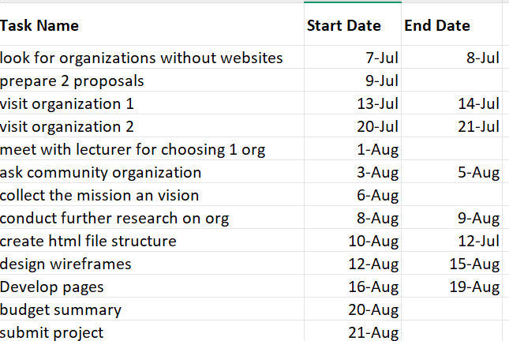

BUDGET

domain registering: R100-R300 annually
Hosting: R50-R200 monthly
SSL certificate: Free
Maintenance : R500-R2500 monthly
SEO services:R2000-R5000 monthly

Name of Organization: Love From Above

Category: non-profit Organization(NPO)

ORGANIZATION OVERVIEW

This organization is a community-based non-profit organization based in Ormonde, Johannesburg South. It has been slowly making waves of change since its inception in 2021. Its mission and vision lies in empowering individuals within communities to take charge of their own development. The organization’s founders, a group of individuals who recognized the gaps in services and resources within their community, came together to address these needs. The target audience of this establishment are the local community members seeking assistance. Potential donors and sponsors, volunteers looking for opportunities to serve and maybe NGOs looking for collaborations.

Website goals and objectives
. Share information about services and initiatives.
· Provide easy access to enquiries and contact forms.
· Showcase services offered to the community.
· Encourage donations and volunteer sign-ups.
· Build credibility and transparency through project updates.

Current website analysis
Love from Above NPO does not have a dedicated website currently. Information is shared via word-of-mouth and social media, which limits reach and credibility. A professional website will centralize communication and improve visibility and credibility.
Proposed website features and functionality
· Homepage (Index): Mission statement, hero image, quick links.
· About Us: History, vision, and team profiles.
· Services: Detailed list of community support, education, and healthcare services.
· Enquiries: Online enquiry form for questions and requests.
· Contact Us: Location map, contact form, and social media links.
· Projects/Impact : Showcase current and past initiatives with images and stories.
Design and user experience
• Clean, welcoming design with warm colors (symbolizing care and compassion).
• Responsive layout for mobile and desktop.
• Simple navigation clear labels.
• Logo prominently displayed in the header.

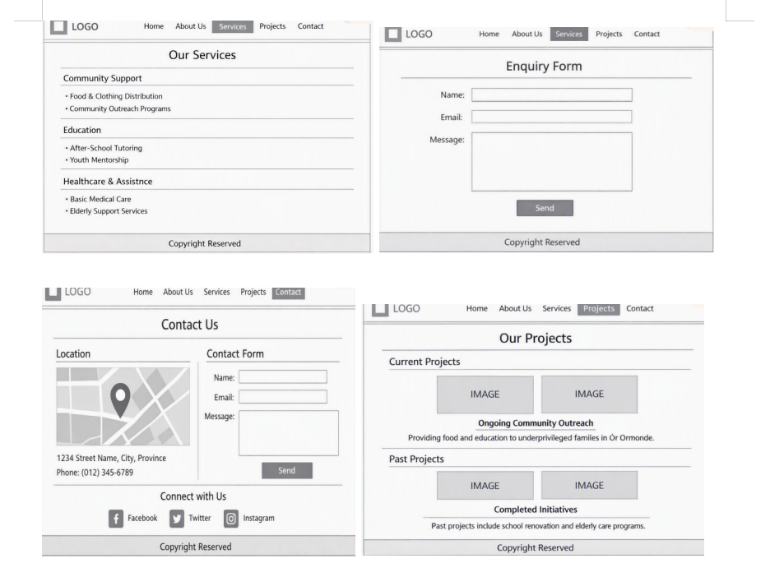
Technical requirements
• HTML5, CSS3, and JavaScript for structure, styling, and interactivity.
• Responsive framework (e.g., Bootstrap).
• Hosting with SSL certificate(to ensure that there is a secure communication between the website and and the visitors) for security.
• Integration with a payment gateway for donations.
• Contact and enquiry forms with basic validation.
Timeline
Budget
* Domain registering(.co.za) and hosting: R200 - R300 annually
*SSL certificate: R300+ annually or can be free via[LE]
*Maintenance: R500 monthly
Total(est)=R21000 for 1st year costs

References

IIE mOdule manual [WEDE5020]
https://www.nngroup.com/articles/nonprofit-usability/
https://www.afrihost.com
Gift of the Givers Foundation (2025) Digital Outreach and Community Impact Report. Cape Town: Gift of the Givers Foundation.

